NOTICE

Subject: Meeting of the Disciplinary Committee.
All Permanent Employees of the Disciplinary Committee constituted vide Order No. 188/2026 dated 31-01-2026 are hereby informed that a meeting of the committee has been scheduled in the office of the Principal on 05-02-2026 at 11:00 a.m.
Agenda:
- To examine the recent incidents at CIIIT Baramulla, particularly the reported misbehaviour by certain day scholars, which has caused serious concern among students — some of whom have expressed their intention to leave the institution — and to assess the broader impact on institutional discipline, student conduct, academic environment, and overall campus harmony.
- To review and discuss the event held within the institution and address related disciplinary concerns.
- To recommend appropriate measures, if required, for maintaining discipline and upholding institutional policies.
Members Concerned:
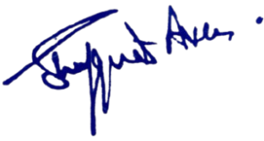
Members are directed to attend the meeting positively along with all the relevant details and contribute to the proceedings.

Principal
Kashmir Government Polytechnic College
Srinagar
No: KGP/Estt/2026/2094
Dated:04-02-2026

Enclosure:
1. Disciplinary Committee Order.

